**DIGITAL MEASURING WHEEL**

**By:** Sinethemba Lusawana

**Highest Qualification**: ND Electrical Engineering

**DECLARATION**

I declare that this document was composed by myself and that the work contained herein is my own except where explicitly stated otherwise in the text.

Name ______________________ Surname __________________________

Date _______________________ Signature _______________________________

1. **INTRODUCTION**
   1. BACKGROUND INFORMATION

Sometimes measuring long distances accurately is necessary. It is very challenging to perform such a task using a measuring tape as it is tiring and has its maximum length.

A measuring wheel can be used to address the issue as it is capable of measuring long distances accurately just by pushing the wheel forward and obtain the distance from point to point in metres. This method is more fun and takes less time.

In this design a measuring wheel has been digitalized to give more accurate output, starting measuring from 0.1 metres (100mm) up to 5000 metres (5km). Unlike the most popular analogue measuring wheels, this digital measuring wheel features additional settings which will be of great importance especially in the field of engineering. This device has two operation methods, Free-mode and Target-mode. In Free-mode the user can just push the device forward and obtain any distance length between 0.1 metres and 5000 metres. Whereas in Target-mode the device is given the specific metres to which it should measure up and notify the user when the destination has been reached.

1.2 MEASUREMENT OBTAINMENT

A rotary encoder is the heart of this device and is utilized to obtain the distance in metres. It is attached physically to the wheel with its rotating shaft. When the wheel rotates the rotary encoder also rotates producing pulses which helps in determining the distance travelled in metres. A very smart algorithm is used in programming the Atmega328P microcontroller with C programming to process the data and give readable and understandable results to the user.

The distance travelled is displayed on the 4 digits seven segments display as shown if figure 4 in methodology. Five red light emitting diodes are used to indicate kilometres travelled from 1km to 5km as shown in figure 3 in methodology. Six push buttons are used to give instruction the device including turning on/off the device, setting target distance and starting/pausing the measuring process. See figure 4 on results.

1. **LITERATURE REVIEW**

A measuring wheel can differ according to its design and its capabilities and features. An analogue measuring wheel is the simplest and arguably the most reliable one as it does not require any electrical power source to do the work, while the digital measuring wheel requires a voltage source ranging from 5V – 12V direct current and offers more advanced features in the interest of the user.

* 1. Analogue Measuring Wheel

Measures distance by utilization of an analogue flipping mechanism.

* 1. Digital Measuring Wheel

Measures distance by utilizing a rotary encoder and Arduino uno and determines the distance by comparing the two pulses generated by the rotary encoder.

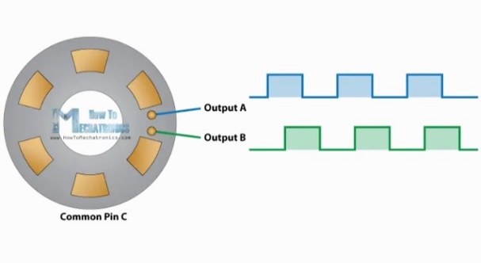

*FIGURE 5: rotary encoder pulses*

1. **DATA COLLECTION**
   1. APPARATUS
2. 1 x ATMEGA238P microcontroller
3. 1x Rotary encoder
4. 1 x 4 digits seven segment display
5. 1 x 5V Active Buzzer
6. 2 x 74HC595 shift registers
7. 5 x Red LEDs
8. 1 x RGB LED
9. 16 x 220 ohm resistors
10. Jumper wires
11. 4 x Push buttons
12. ON/OFF switch
13. 12V Battery
14. 4 x NPN transistors
15. Wheel
    1. SPECIFICATIONS
16. 12V DC Power supply
17. Measures from 0.1m – 5000m
18. Battery life approximately 5 hrs @Full load (to be calculated)
19. **METHODOLOGY**

4.1 BLOCK DIAGRAM

ATMEGA328

Microcontroller

9V DC POWER

4 X BUTTONS

ROTARY ENCODER

4 DIGITS 7 SEGMENT DISPLAY

5 X RED LEDs

5V ACTIVE BUZZER

*FIGURE 3: Block diagram of digital measuring wheel*

4.2 CIRCUIT DIAGRAM

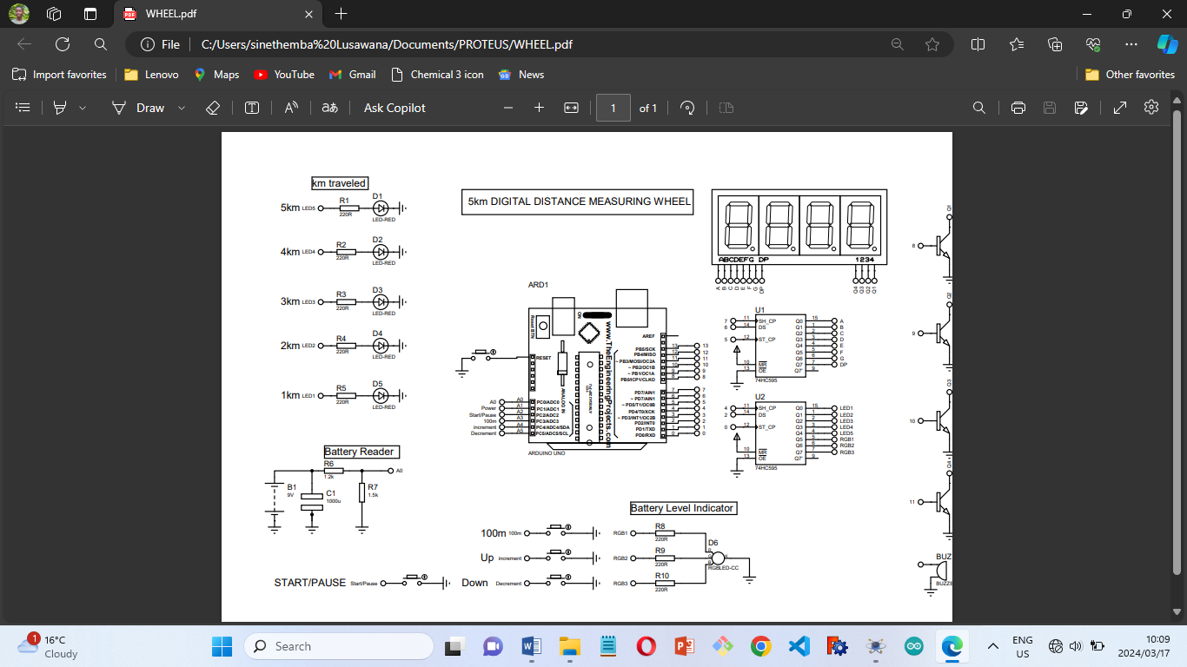

*FIGURE 5: Circuit diagram of digital distance measuring wheel on proteus 11*

4.3 FLOWCHART

1. **DESIGN CALCULATIONS**

5.1 BATTERY READER



*FIGURE 6: Battery reader circuit*

The voltage at is 5V only if the input voltage . As decreases will decrease too until they both reach their lowest voltage values.

1. **ANALYSIS AND DESIGN**

**5.1 SIMULATION ON PROTEUS**

After building the schematic diagram some portion of the project was taken to proteus software for simulation to observe its behaviour and output.

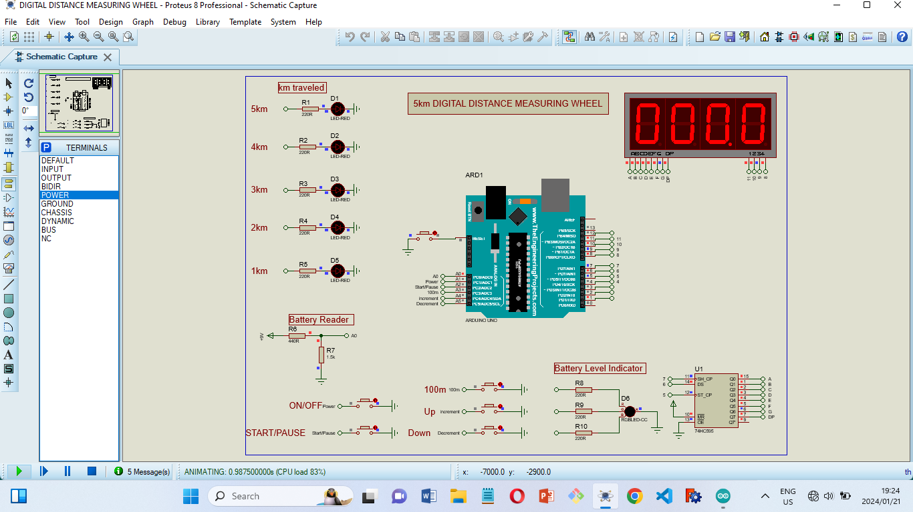

*FIGURE 6: Simulation on Proteus 8*

It can be seen on the picture that just after energizing the circuit, the display will display 0s, which shows that measurement has not started.

The purpose of the simulation was also to observe the behaviour of the battery as it will lose its power with time as it powers the circuit. There is a light emitting diode (LED, RGB) indicator which indicates when the battery is GOOD, FAIR and LOW. See figure 7

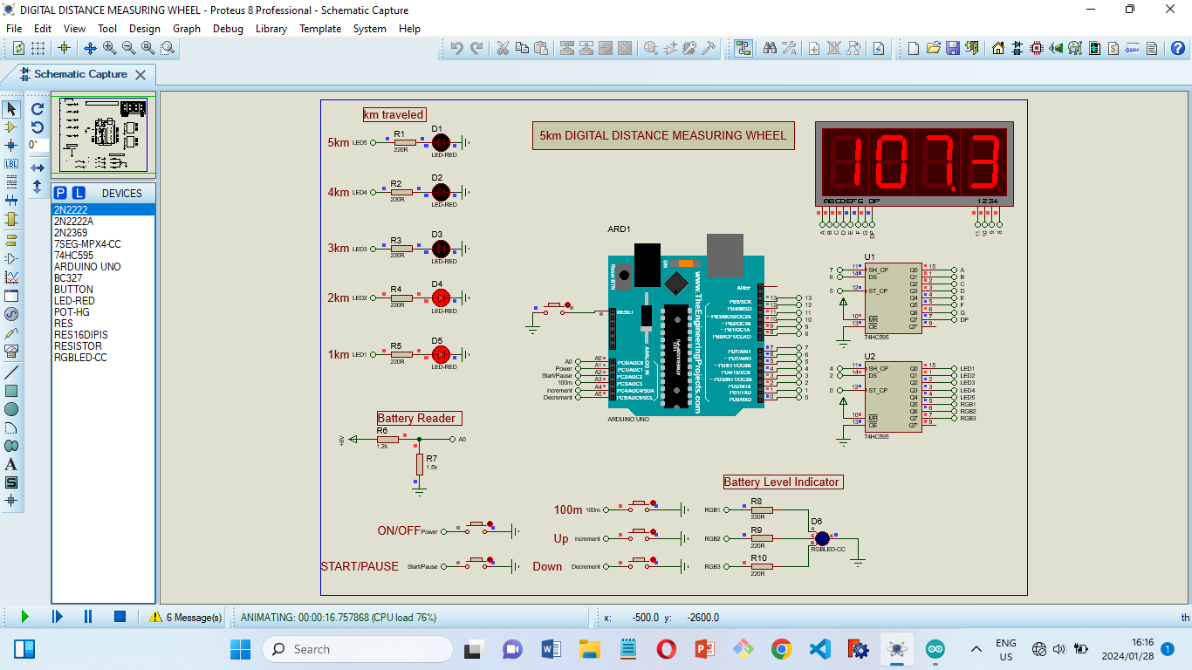

*FIGURE 7: Battery level indication and setup*

It must be kept in mind that this design features the ability to set the target distance and be notified at the destination. In the figure above it can be seen that the numbers on the display has changed to **107.3m** which is the target distance to be travelled by the user.

**5.2 IMPLEMENTATION**

Since the project was working as expected on Proteus 8 Software, it was then the time to build it on the breadboard to actually see the result and perform some practical tests.

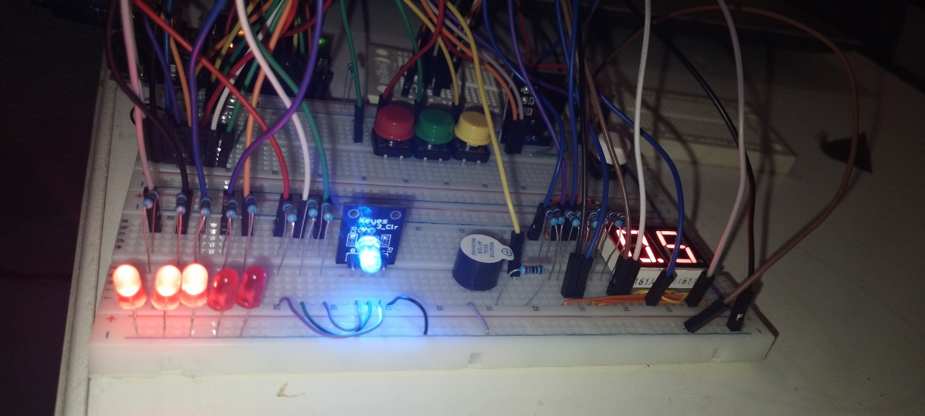

*FIGURE 8: Implementation on breadboard*

5.2.1 BATTERY LEVEL INDICATOR



*FIGURE 9: Battery level RGB indicator*

Blue indication = GOOD

Green indication = FAIR

Red indication = LOW

5.2.2 MEASUREMENT DISPLAY



*FIGURE 9: Measurement display (two 7 segment display missing)*

Displays up to **999.9**

5.2.3 KILOMETERS TRAVELLED INDICATOR



FIGURE 10: 5 LEDs 1km – 5km indication

In the figure above **3km** distance travelled is indicated. We should remember to add it with the distance displayed on the 7 segment display, which will result into **3.005km.**

5.2.4 BUZZER NOTIFIER



*FIGURE 11: Active buzzer notification*

5..2.5 SETUP BUTTONS



*FIGURE 11: 3 setup push buttons plus 1 start/pause push button*

1. **ANALYSIS OF RESULTS**

6.1 DISTANCE MEASUREMENT

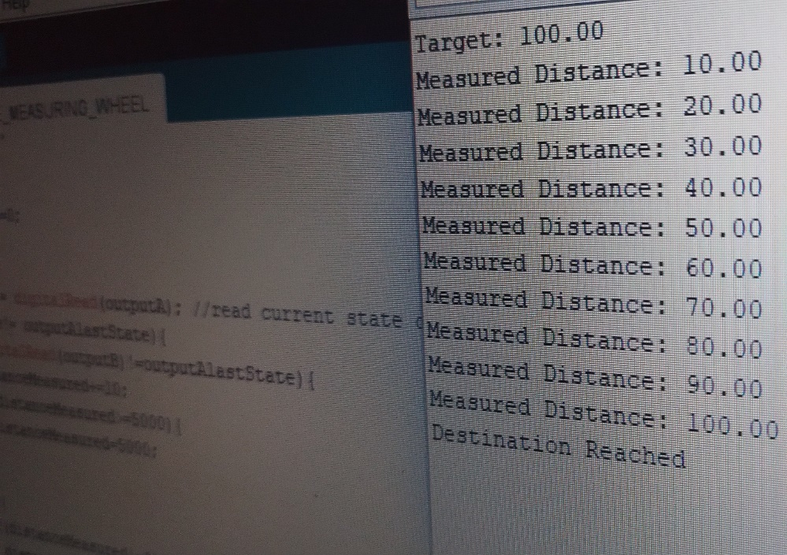

*FIGURE 12: Results on Arduino IDE Serial Monitor*

Each step was set to be 10 meters for testing purposes. The target distance was set to be 100 meters and when this target distance was reached a message was provided triggering the buzzer at the same for notification.

1. **CONCLUSION**

Measuring distance has never been this easier. With just pushing a toy forward distance is obtained and work done. Being able to instruct it according to the distance the user would like to measure is very helpful as a reminder as it can be stressful at work and taking that walk can lead to forgetting the mission.

**APPENDIX A –** CODE

**APPENDIX B -** SCHEMATIC DIAGRAM



1. **REFERENCES**